**Steps for creating Custom Connector**

1. Navigate to Custom connector in Flow as

<https://india.flow.microsoft.com/manage/environments/Default-07686ea2-1fa1-4a06-b8c1-38e2e1b964a2/connections/custom/>

Click on create custom connector > Give any name

1. For Import file, select the file attached with this file. You will get screen as

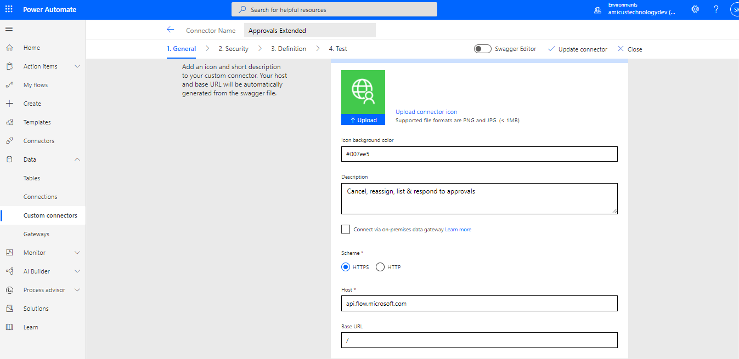

1. Navigate to security tab, and need to create Client ID and secret.
2. Navigate to azure portal, and click on new registration and Provide any name(I have used approvals as name) and click on register.

<https://portal.azure.com/#blade/Microsoft_AAD_RegisteredApps/ApplicationsListBlade>

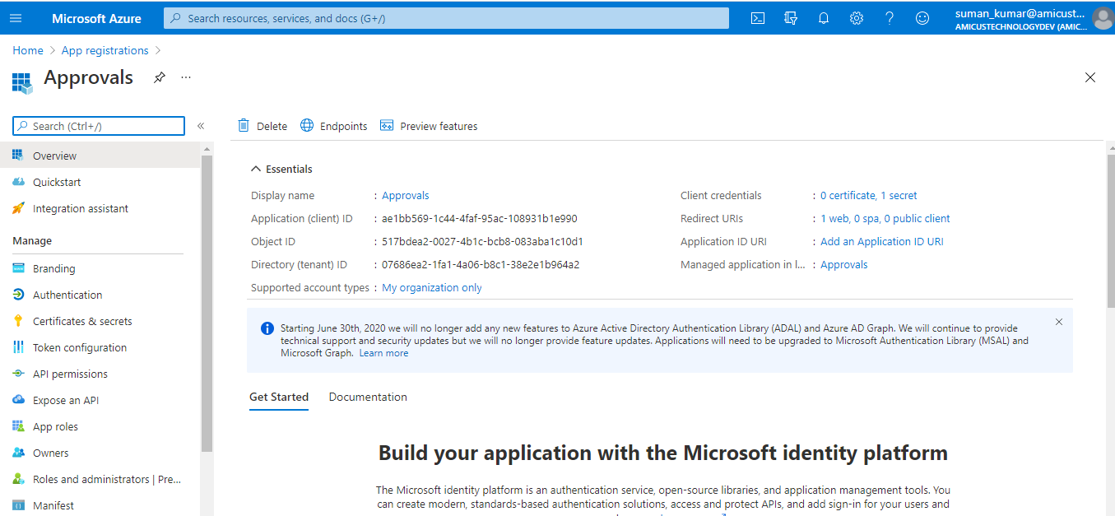

1. Click on Approvals, Copy Client ID and Tenant ID and paste on Step 3 page, against Client ID and Tenant ID.
2. For Certificates, navigate to “Certificates and Secrets” from left navigation and click on new client secret. Give any name to secret and keep expiry as 1 year. Click Add
3. Copy the value of Secret by clicking on clipboard, and paste on Step 3 page, against Client Secret

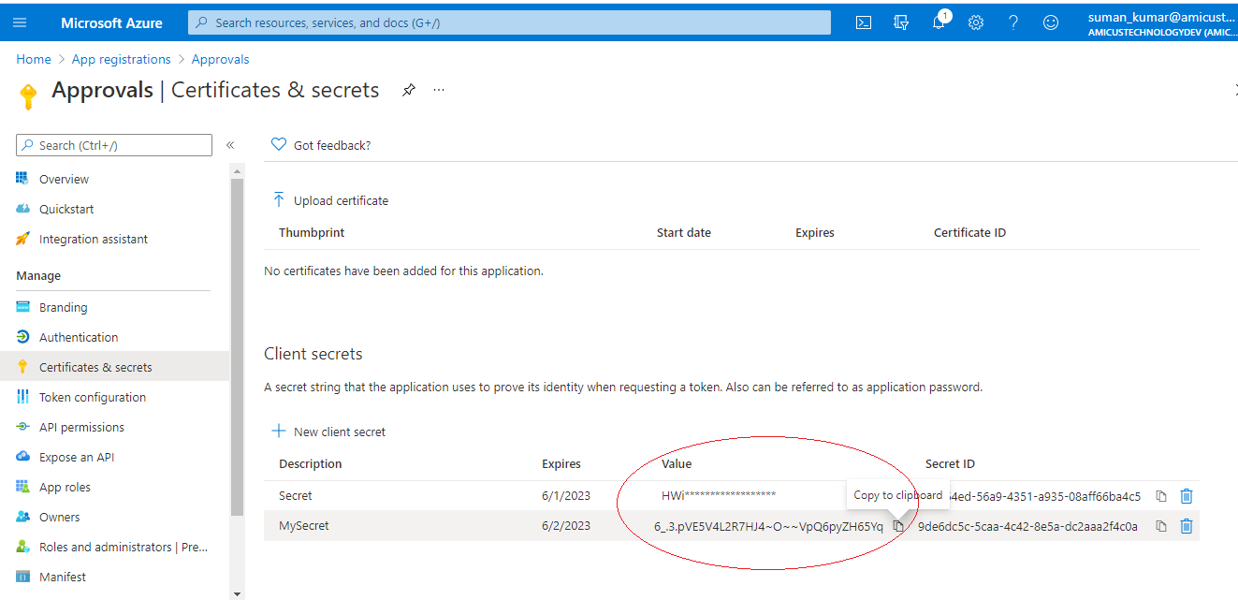

1. Navigate to API permission from left tab, and click on add permission. > Select Flow Service.
2. For Request API permission, Select both option under approvals. Also select User under other permission. And click add.

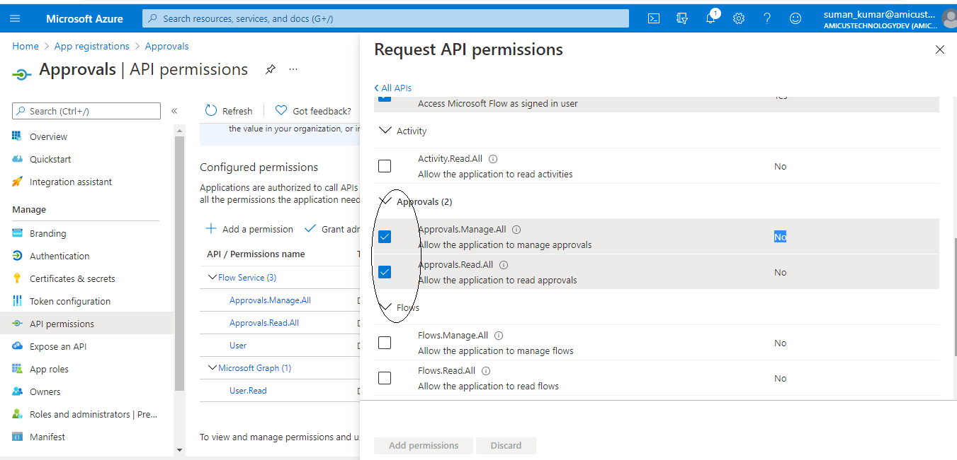

1. Click On Grant admin consent from ribbon on same page after step 9 above.
2. Click on create connector and copy the Redirect URL in step 3.

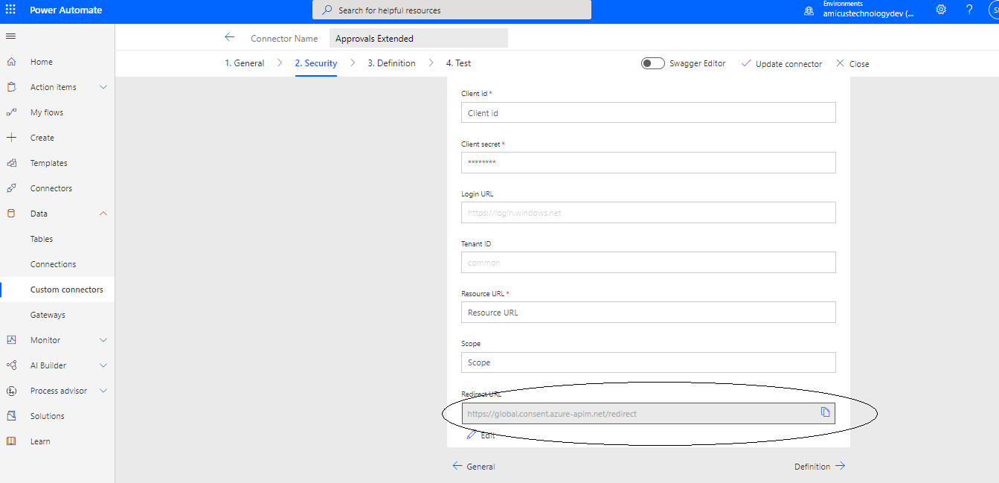

1. Go back to Azure tab, click Authentication form left tab > Add a Platform > Select Web
2. Provde <https://global.consent.azure-apim.net/redirect> as URL > Configure
3. For testing, Naviagte to Test Tab

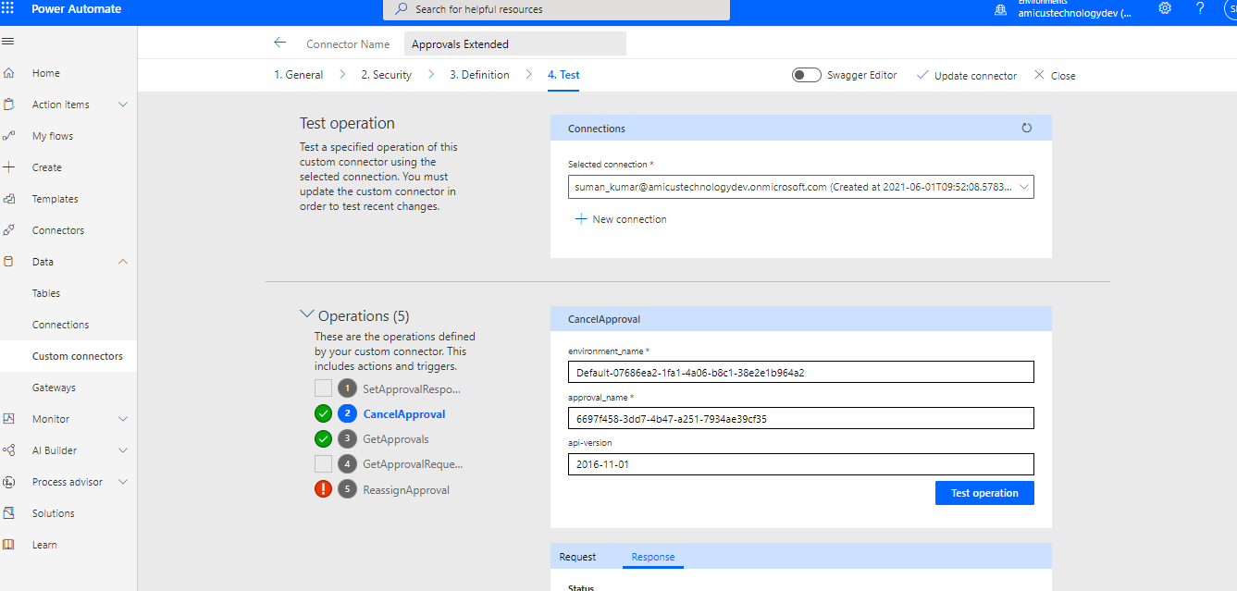

You should see all these 5 actions and can select and operation from these.